**Youth Justice Management Board – 25th September 2015**

**Lancashire YOT Performance Report**

1. 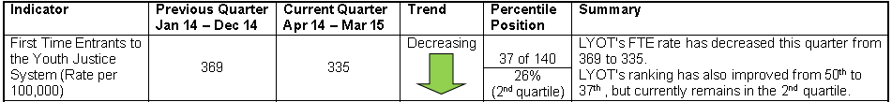**National Indicator: First Time Entrants**

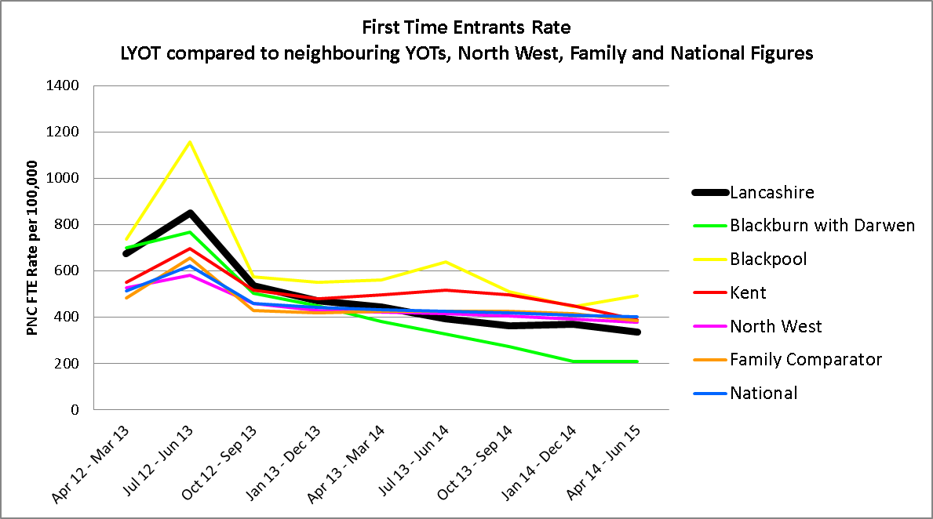

|  |
| --- |
|  |
|  |



**Data Analysis**

The underlying trend for FTEs has been reducing since 2007. This is a trend which has been mirrored by all the comparators in the same period. The last quarter has seen a slight decrease in the FTE rate from 369 to 335 for the period April 2014 to June 2015. This now places LYOT within the 2nd quartile – ranked 37th out of 140 YOTs.

LYOT's performance is better than all 3 comparators – North West, Family and National.

All LYOT teams have seen a decrease in the FTE rate for the current quarter with the exception of the East Team.

1. 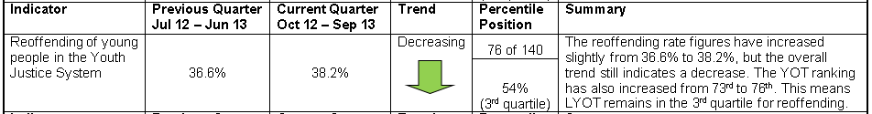**National Indicator: Recidivism**

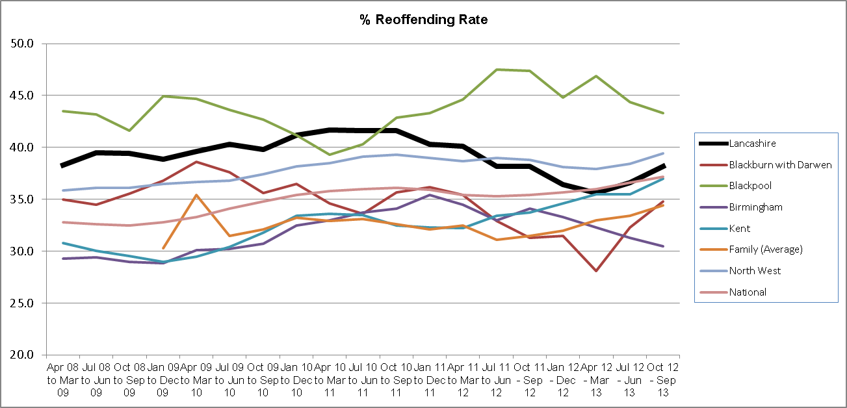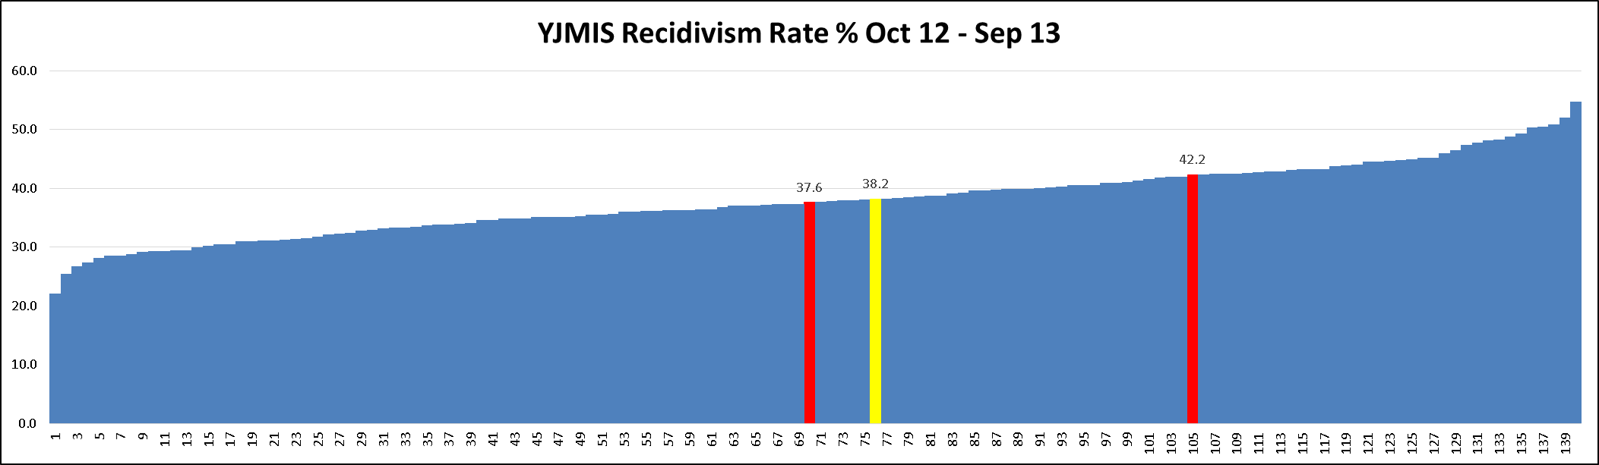

|  |
| --- |
|  |
|  |
|  |

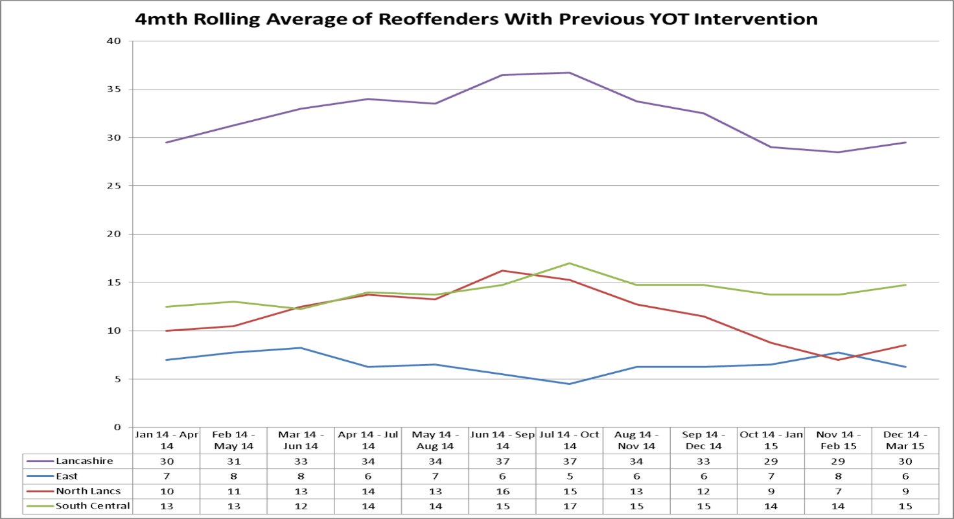

**Data Analysis**

The underlying trend for reoffending has now been decreasing since 2011. Prior to this point in time LYOT's underlying trend has been increasing since the introduction of this measure in 2005. The reoffending rate for this quarter, October 2012 to September 2013, is 38.2% which is an increase of 1.6% compared to last quarter. This keeps LYOT in the 3rd quartile. The new ranking position is 76 out of 140 YOTs.

LYOT's reoffending rate remains lower than the North-West comparator; however it higher than the Family comparator and National comparators

The local 'real-time' reoffending tally measure has seen 'reoffending' levels remain relatively stable since Nov 2013.

1. 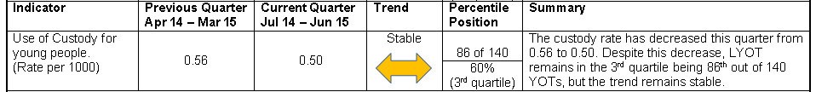**National Indicator: Reducing the Use of Custody**

|  |  |  |
| --- | --- | --- |
|  |  |  |
|  |  |  |



**Data Analysis**

The underlying trend for LYOT's Custody has been stable since 2012. The last quarter has seen another slight decrease in custody from 0.56 to 0.50. Custody rates have been very good in Lancashire and this trend continues with LYOTs ranking being 86th out of 140 YOTs – placing LYOT in the third quartile.

LYOT's custody rate is marginally higher than all the comparator figures.

Custody figures remain low in all our teams with only a slight increase I the East from 2 to 5 young people.

**Current LYOT Operational Analysis – key points**

To further support the data analysis of the three national indicators, each of the three YOT teams carry out a local team analysis meeting each quarter. At these meetings, the relevant team operational managers, practitioners and performance officers discuss and identify key operational issues which are impacting either directly or indirectly on performance. The meetings primarily focus on the 3 national indicators, local measures and national standards.

Below are the key themes and issues emerging from these meetings based on exception reporting:

**LYOT North Team**

The first time entrants' rate continues to decrease in the North together with increases in triage figures. This indicates effective use of triage as an alternative to court action.

The Lancashire MOJ rate which is 18 months behind, has seen an increase in reoffending. This correlates with the five young people who had received ASBOs and then subsequently went on to commit a high number of offences.

Custody rates have remained static for a long time now and of the 3 young people who received custody: one was 19 years old at sentence and the other two were as a result of the serious nature of their offending and breach of their ISS requirements.

National standards compliance was very good at 81%.

**South Central Team**

There has been a number of personnel changes within the South Central team in recent months. A new Team Manager started in April and a Practice Manager left in May, to be replaced in July.

The last quarter has seen an increase in the number of new orders starting. The team also continues to manage a high caseload of young people who are assessed as a high or very high risk of serious harm to themselves (25 young people), those assessed as high risk of harm to others (18 young people) and five MAPPA cases.

The first time entrants' rate is still deceasing in the team. This is testament to the work done by the Police Officers delivering training sessions to other Police colleagues in the division as alternatives to out of court disposals, such as community resolution, triage and restorative justice options.

Reoffending is the highest in the county for the South Central Team. The team are planning some 'deep dive' analysis to determine some of the underlying causes of this.

Custody levels have reduced in the last quarter, however remain the highest for the county. Unfortunately despite robust alternatives to custody being recommended, most of the cases inevitably received custody due to the serious nature of the offending. Only one custody panel meeting took place last quarter and the team are to ensure that these are completed in all instances.

National standards compliance was very good at 81%.

**East Team**

The first time entrants' rate has seen a slight increase for the quarter to 56 young people per 100,000 of the 10-17 population. This is the highest rate in the county however significantly lower than previous historical rates. This is not a consistent trend across all district in the area. There is a view that inconsistent outcomes from the two Out of Court Disposal Panels (Burnley & Hyndburn) may be having an impact. This is being addressed by the attendance of a practice manager which is helping to achieve greater equity in process between the two panels.

The local reoffending rate has reduced for the East in the last quarter. The use of constructive and creative activities in the area has seen an increase in engagement with young people, in contrast to the usual office-based intervention. Activities have included:

* Work sessions with the Canal & Rivers Trust to make bird boxes and clearing ground near the canal;
* Cookery events – enabling young people to learn valuable life skills;
* Sports sessions such as football, rugby (non-contact) and arts activities.

Custody has slightly increased in the current quarter, however still remains low and stable. Robust community packages were proposed to the courts, however the seriousness of the offending resulted in an inevitable custodial sentence.

National standards compliance was very good at 83%.

Mukhtar Master,  
Performance & Information Manager,  
September 2015.